**Insecure Protocols**

***Misc***

**Challenge:**

I just spun up my first website with a login page and everything! My friend tells me my page isn't secure and I'm not sure why.

Attached - insecure.pcapng

**Approach:**

Basic traffic analysis actually, we open the .pcapng file on the wireshark as the first step.

If we open up protocol hierarchy we’ll see the different types of packets that were captured:

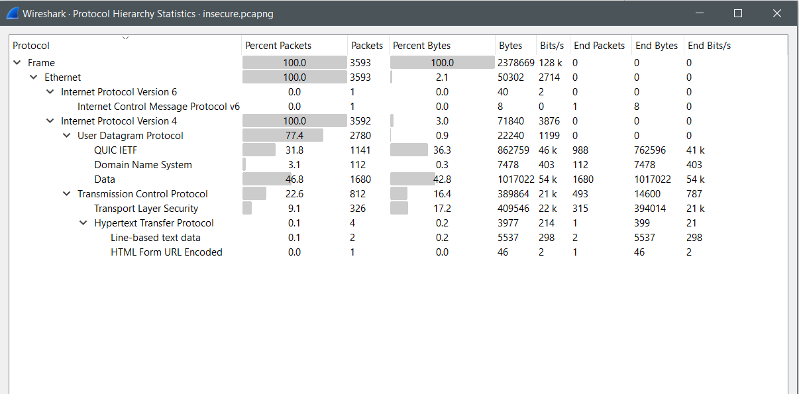

In this what grabbed my attention was the HTTP data sent, especially the HTML form data. As the question talks about website with login page i figured this is where the vulnerability would probably be. We open up that specific packet and see the flag as the uname parameter:

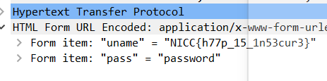

Hence the flag:

**Flag: NICC{h77p_15_1n53cur3}**

Congrats!!

Happy Hacking!